The presentation for trainees in Dalian

Feng Jin

Exported on Aug 15, 2019

Table of Contents

1 /*<![CDATA[*/ div.rbtoc1565847511732 {padding: 0px;} div.rbtoc1565847511732 ul {list-style: disc;margin-left: 0px;} div.rbtoc1565847511732 li {margin-left: 0px;padding-left: 0px;} /*]]>*/ 3

2 Version 4

3 Introduction 5

4 The Overview of IVI OSes 6

5 The Overview of Self-Driving Vehicle 7

6 The Internals of IVI 8

6.1 Work Flow 8

6.2 Requirement 8

6.3 Product 8

6.4 Architecture 9

6.4.1 System Architecture 9

6.4.2 Hardware Architecture 9

6.4.3 Software Architecture 10

6.5 Software Layers 10

6.6 Booting 11

7 How to become a qualified software engineer 12

7.1 Attitude 12

7.2 Diligence 12

7.3 Ability 12

7.3.1 Basics 12

7.3.2 BSP Engineer 12

7.3.3 Framework Engineer 12

7.3.4 Application Engineer 12

7.4 Experiences 13

8 Conclusion 14

# /*<![CDATA[*/ div.rbtoc1565847511732 {padding: 0px;} div.rbtoc1565847511732 ul {list-style: disc;margin-left: 0px;} div.rbtoc1565847511732 li {margin-left: 0px;padding-left: 0px;} /*]]>*/

* Version
* Introduction
* The Overview of IVI OSes
* The Overview of Self-Driving Vehicle
* The Internals of IVI
  + Work Flow
  + Requirement
  + Product
  + Architecture
    - System Architecture
    - Hardware Architecture
    - Software Architecture
  + Software Layers
  + Booting
* How to become a qualified software engineer
  + Attitude
  + Diligence
  + Ability
    - Basics
    - BSP Engineer
    - Framework Engineer
    - Application Engineer
  + Experiences
* Conclusion

# Version

|  |  |  |
| --- | --- | --- |
| Author | Version | Changes |
| Jin Feng | 0.1 | Initial Draft |

# Introduction

* Self-introduction
* The trends of vehicle electronic devices
  + IVI
  + Telematics
  + Self-driving

# The Overview of IVI OSes

<http://10.57.9.140:8090/display/~feng_j1/The+Overview+of+IVI+OSes>

# The Overview of Self-Driving Vehicle

<http://10.57.9.140:8090/display/~feng_j1/The+Overview+of+Self-Driving+Vehicle>

# The Internals of IVI

## Work Flow

<http://10.57.9.140:8090/display/~feng_j1/An+elastic+organizational+structure+for+software+companies#Anelasticorganizationalstructureforsoftwarecompanies-WorkFlow>

## Requirement

[LAH_CNS3.0_Navi_function_Map Display_V01e_20171106_wanghs.pdf](http://10.57.9.140:8090/download/attachments/32252414/LAH_CNS3.0_Navi_function_Map%20Display_V01e_20171106_wanghs.pdf?api=v2&modificationDate=1564121756000&version=1)

## Product

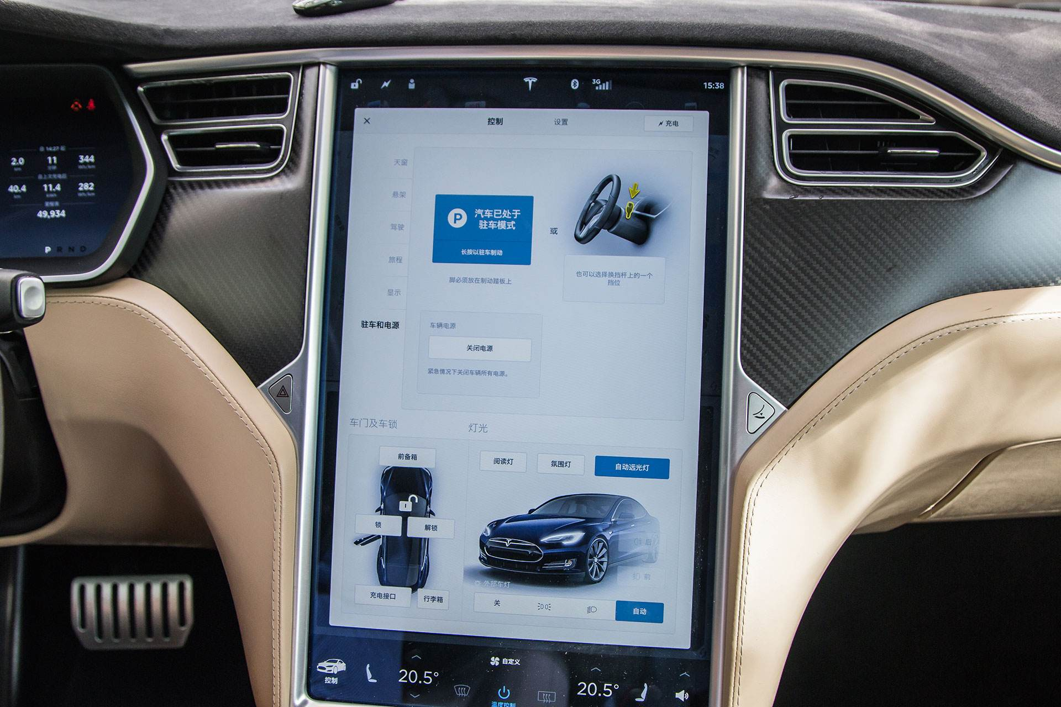

## Architecture

### System Architecture

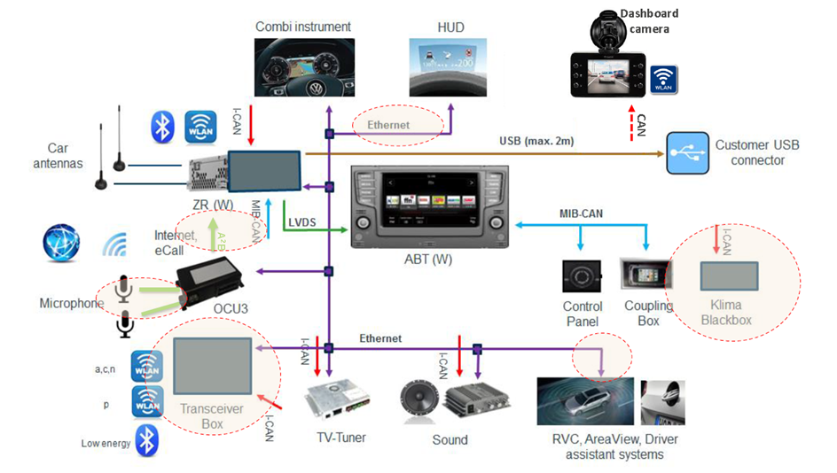

### Hardware Architecture

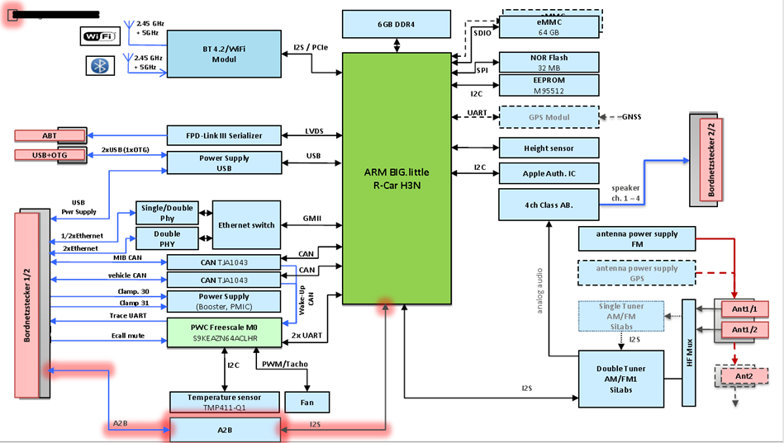

### Software Architecture

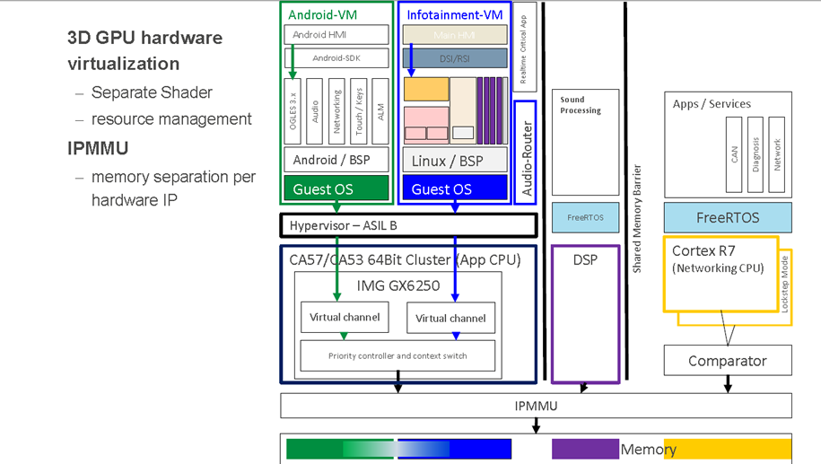

## Software Layers

BSP, Framework, and Application

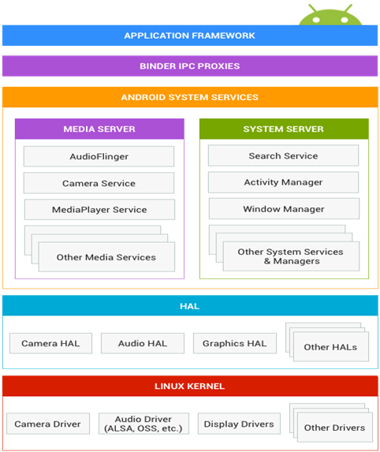

## Booting

<http://10.57.9.140:8090/pages/viewpage.action?pageId=16527898>

# How to become a qualified software engineer

## Attitude

* Willing to learn
* take initiative and responsibility, ownership

## Diligence

* Your growth is determined by the time after work

## Ability

### Basics

* Logic
* Communication (English)
* Date Structure and Algorithms  
  Introduction to Algorithms:  <https://book.douban.com/subject/1433399/>
* Language  
  C:  The C Programming Language:  <https://book.douban.com/subject/25735837/>  
  C++: The C++ Programming Language: <https://book.douban.com/subject/7053134/>
* Software Engineering  
  Code Complete: <https://book.douban.com/subject/1951158/>  
  The Mythical Man-Month: <https://book.douban.com/subject/1105381/>  
  Design Patterns: <https://book.douban.com/subject/1099305/>
* Tools  
  Shell script  
  Make&CMake  
  git

### BSP Engineer

* Advanced Programming in the UNIX Environment: <https://book.douban.com/subject/25900403/>
* Linux Device Dirvers: <https://book.douban.com/subject/1493443/>
* Linux Kernel Development: <https://book.douban.com/subject/1503819/>

### Framework Engineer

Todo

### Application Engineer

Todo

## Experiences

The more projects, the more experiences.

# Conclusion

唯天下之至拙，能胜天下之至巧